1. Create simple graphical user interfaces with checkboxes, radio buttons, combo boxes, and lists as shown in Figure 1. Figure 1

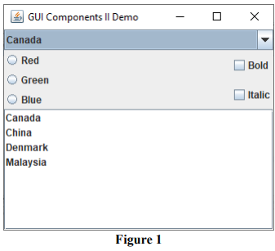

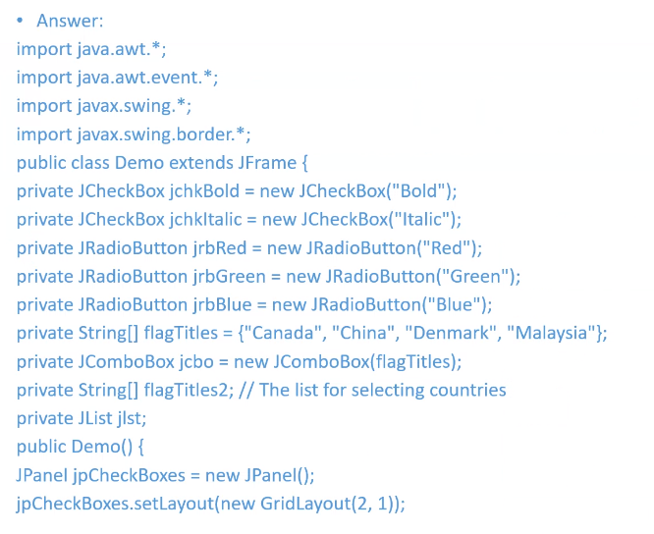

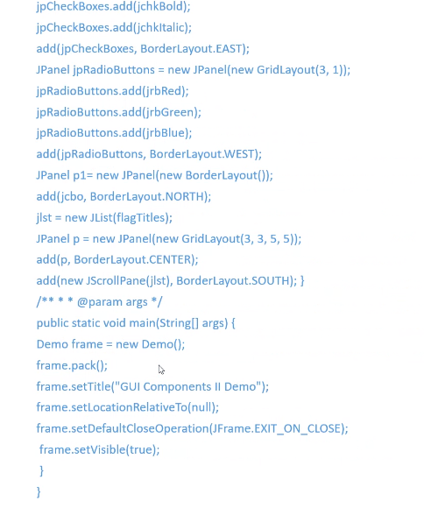

2. Explain how the following types of events are triggered:

a) **Checkbox Events**

* When a JCheckBox is clicked (checked or unchecked), it fires an ItemEvent that invoked itemStateChanged() and then the actionPerformed() handler for ActionEvent

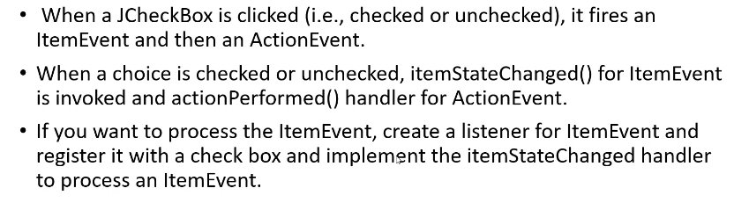

b) **JComboBox Events**

* Whenever an item is selected, an ActionEvent is fired.
* No ItemEvent will be fired if the current item is reselected

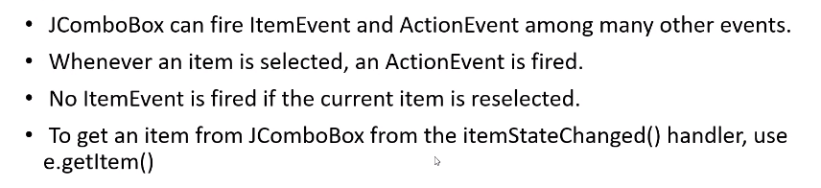

3. Specify the steps to Create multiple windows in an application.

1. Create the main window by defining a main class for the frame which must have a button that will invoke the sub window and add it to the frame.
2. Create the sub window by defining a subclass of JPanel.
3. Implement the actionPerformed handler in the main window.

* Create an instance of the subwindow.
* Add the sub window object to the main window and make it visible.

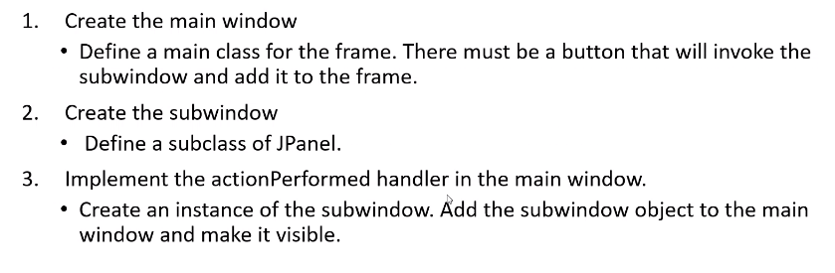

4. Write code to create and add a JMenuBar to a frame.

JFrame f = new JFrame();

f.setSize(300, 200);

f.setVisible(true);

JMenuBar mb = new JMenuBar();

f.setJMenuBar(mb);

5. Write code creates two menus, File and Help, and adds them to the JMenuBar mb.

JMenu fileMenu = new JMenu("File");

JMenu helpMenu = new JMenu("Help");

mb.add(fileMenu);

mb.add(helpMenu);

6. Write code adds menu items and item separators in menu fileMenu

fileMenu.add(new JMenuItem("new"));

fileMenu.add(new JMenuItem("open"));

fileMenu.addSeparator();

fileMenu.add(new JMenuItem("print"));

fileMenu.add(new JMenuItem("exit"));

fileMenu.addSeparator();

JMenuBar

JMenu

JMenuItem